*Florida International University*

*School of Computing and Information Sciences*

Software Engineering Focus

Feature Document

User Story #156

**Team Member:**

Giselle Pacheco

**Product Owner(s)**:

Mohsen Taheri

**Mentor(s)**:

Mohsen Taheri

**Instructor**: Masoud Sadjadi

**User Story** Add Task.

* As a User I would like to be able to add task so I can keep track of assignments

Acceptance Criteria

* Have input for assignment name, and due date
* Have a done button that once pressed adds assignment to a list
* Hit the assignment endpoint in order to add the assignment

**Use Case** #**156– Add Task**

Details:

Actor: Student

Pre-conditions:

1. Student is logged in
2. Student has created a class
3. Student has at least 1 assignment on dashboard

Description:

1. Use case begins when student clicks on an assignment
2. System displays a List of tasks
3. Student presses the add task button
4. Student enters a name for the task and a due date
5. Student clicks the done button
6. Use case ends when student sees new task displayed on assignment View

Post-conditions:

1. Student sees sees a list of task with the new task added to the list

Alternative Courses of Action

Exceptions:

Related Use Cases:

**Use Case Diagram**

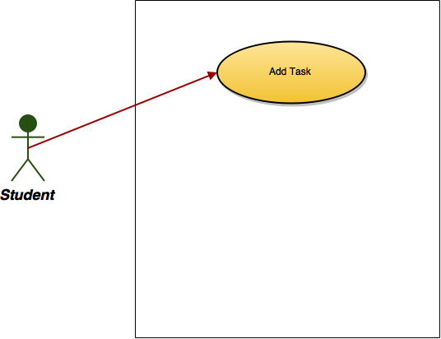

**Sequence Diagram**

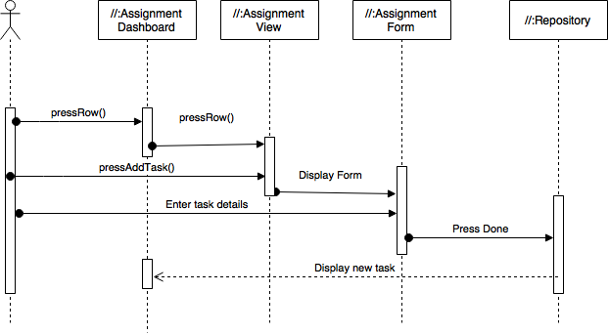

**Class Diagram**

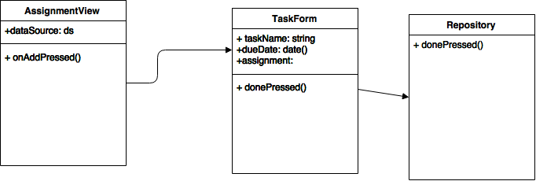

**Unit Test**

**Test Case 1 (Sunny Day)**

**Purpose**

* Ensure that a user can add an task

**Precondition**

* User is logged in
* User has added a class
* User is part of a school
* User has at least one assignment on dashboard

**Input**

* task Name
* Due date of the task

**Expected Result**

* User can see an added task on the assignment view

**Actual Result**

* Added task on the on the assignment view

**Test Case 2 (Sunny Day)**

**Purpose**

* Ensure that there is a default due date

**Precondition**

* User is logged in
* User has added a class
* User is part of a school
* User has added at least 1 assignment

**Input**

* User inputs an task name

**Expected Result**

* Assignment is added with the default due date

**Actual Result**

* Assignment is added

**Test Case 3 (Rainy Day)**

**Purpose**

* Ensure that if a user does not enter an assignment name, assignment is not added

**Precondition**

* User is logged in
* User has added a class
* User is part of a school

**Input**

* Due date of the assignment

**Expected Result**

* App stays on the Assignment form page

**Actual Result**

* App stays on assignment page

**Visual User Guide**